BANK CRM

OBJECTIVE QUESTIONS
- What is the distribution of account balances across different regions?
ANS:
Tool Used: Power BI
Customers in Germany maintain significantly higher average account balances (~120K) compared to France and Spain (~62K each). This indicates that the German customer segment holds higher value accounts and may represent a more profitable market for the bank.
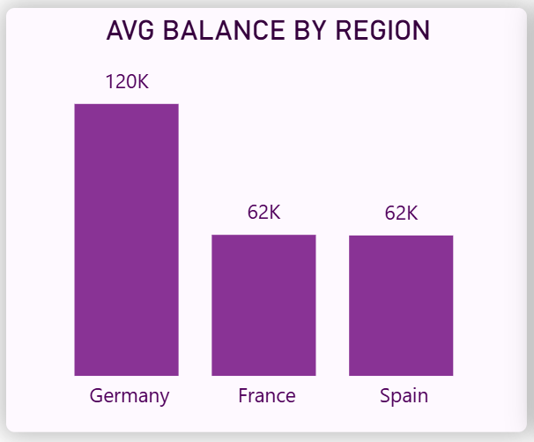
Fig 1

- Identify the top 5 customers with the highest Estimated in the last quarter of the year.
ANS:

Query Used:
SELECT CustomerId, Surname, EstimatedSalary
FROM bank_churn
WHERE MONTH(`Bank DOJ`) BETWEEN 10 AND 12
ORDER BY EstimatedSalary DESC
LIMIT 5;

OUTPUT:

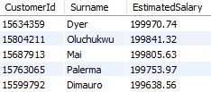
INSIGHT:
The analysis shows that the top five customers with the highest estimated salaries earn between ~199K and ~200K annually. Customers Dyer, Oludchukwu, and Mai have the highest estimated salaries, indicating that these individuals belong to a high-income customer segment, which may represent valuable clients for premium banking services.

- Calculate the average number of products used by customers who have a credit card (SQL).
ANS:
Query Used:
SELECT AVG(NumOfProducts) AS Avg_Products_CreditCard
FROM Bank_Churn
WHERE HasCrCard = 1;

OUTPUT:
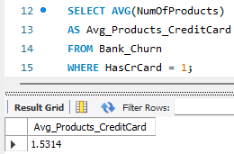
INSIGHT:
- Customers with a credit card use about 1.53 products on average.
- This indicates that most credit card holders typically use one or two banking products.
- It suggests moderate product engagement among credit card customers.

- Determine the churn rate by gender for the most recent year in the dataset?
ANS:
Tool Used: Power BI
Churn rate is the percentage of customers who have exited the bank compared to the total number of customers in a specific period. For this analysis, the most recent year in the dataset is considered based on the Bank DOJ column.
Formulas Used:
1. Extract Year from Bank DOJ
- Year = YEAR('Bank_Churn'[Bank DOJ])
- This column is created to identify the year when customers joined the bank.
2. Churn Rate Calculation
- Churn Rate = AVERAGE('Bank_Churn'[Exited]) * 100
- Since the Exited column contains values 1 (Exited) and 0 (Retained), taking the average gives the proportion of customers who exited.

Visualization:
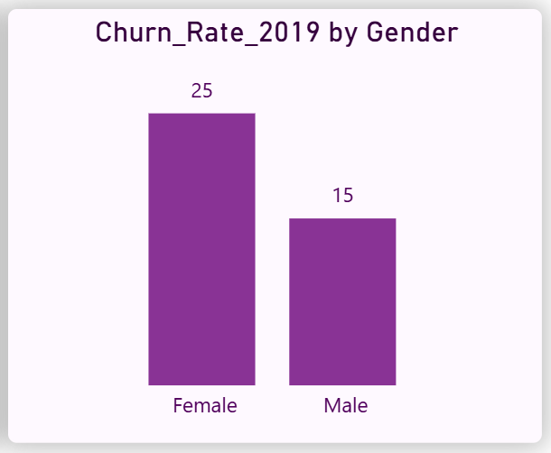
Fig 2
INSIGHT:
- Female customers have a higher churn rate of approximately 25%, whereas male customers have a churn rate of around 15% in the most recent year.
- This suggests that female customers are leaving the bank at a higher rate compared to male customers.
- Understanding the factors contributing to this difference can help the bank develop targeted customer retention strategies.

- Compare the average credit score of customers who have exited and those who remain. (SQL)

ANS:
Query Used:
SELECT
Exited,
AVG(CreditScore) AS Avg_CreditScore
FROM Bank_Churn
GROUP BY Exited;

This query groups customers based on their exit status and calculates the average credit score for each group.

OUTPUT:
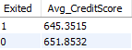
- Exited = 1 → Customers who left the bank
- Exited = 0 → Customers who remained with the bank

INSIGHT:
- Customers who remained with the bank have a slightly higher average credit score (651.85) compared to customers who exited (645.35).
- This suggests that customers with stronger credit profiles may be slightly more likely to stay with the bank.
- However, the difference is relatively small, indicating that credit score alone may not be a major factor influencing churn.

- Which gender has a higher average estimated salary, and how does it relate to the number of active accounts?

ANS:
Query Used:
SELECT
GenderCategory,
AVG(EstimatedSalary) AS Avg_Salary,
SUM(IsActiveMember) AS Active_Accounts
FROM Bank_Churn
GROUP BY GenderCategory;

This query calculates the average salary for each gender and counts the number of active members.

OUTPUT:
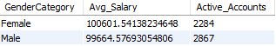
INSIGHT:
- Female customers have a slightly higher average estimated salary (100601.54) compared to male customers (99664.58).
- However, male customers have a higher number of active accounts (2867) compared to female customers (2284).
- This indicates that despite having a slightly lower average salary, male customers tend to be more actively engaged with the bank.

- Segment the customers based on their credit score and identify the segment with the highest exit rate?

ANS:
Query Used:
SELECT
CreditScoreGroup,
COUNT(CustomerId) AS Total_Customers,
SUM(Exited) AS Exited_Customers,
ROUND((SUM(Exited) / COUNT(CustomerId)) * 100,2) AS Exit_Rate
FROM Bank_Churn
GROUP BY CreditScoreGroup
ORDER BY Exit_Rate DESC;

This query calculates the number of customers, number of exited customers, and the exit rate for each credit score segment.

OUTPUT:
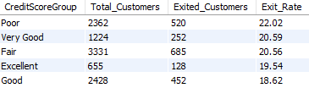
INSIGHT:
- Customers in the Poor credit score segment have the highest exit rate at 22.02%.
- In contrast, customers with Good credit scores have the lowest exit rate at 18.62%.
- This suggests that customers with lower credit scores may be slightly more likely to leave the bank compared to those with better credit profiles.
- Find out which geographic region has the highest number of active customers with a tenure greater than 5 years?

ANS:
Query Used:
SELECT
GeographyLocation,
COUNT(CustomerId) AS Active_Customers
FROM Bank_Churn
WHERE IsActiveMember = 1
AND Tenure > 5
GROUP BY GeographyLocation
ORDER BY Active_Customers DESC;

This query filters customers who are active members and have a tenure greater than five years, then counts them by geographic location.

OUTPUT:
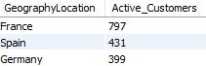
INSIGHT:
- France has the highest number of active customers with a tenure greater than five years, totaling 797 customers.
- Spain and Germany follow with 431 and 399 customers respectively.
- This indicates that France has a stronger base of long-term active customers compared to the other regions.

- What is the impact of having a credit card on customer churn?
ANS:
Tool Used: Power BI
This analysis compares the churn rate between customers who have a credit card and those who do not.
Formulas Used:
- Churn Rate = AVERAGE('Bank_Churn'[Exited]) * 100)
- The Exited column contains values 1 (Exited) and 0 (Retained)
- Taking the average of this column gives the percentage of customers who have exited.

Visualization:
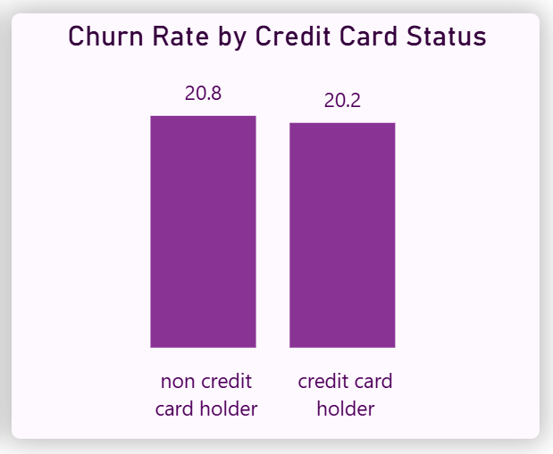
Fig 3
INSIGHT:
- Customers without a credit card have a churn rate of approximately 20.8%, while customers who have a credit card show a slightly lower churn rate of around 20.2%.
- This indicates that credit card holders are marginally more likely to stay with the bank.
- However, the difference is relatively small, suggesting that credit card ownership does not have a strong impact on customer churn.

10.What is the impact of having a credit card on customer churn?
ANS:
Tool Used: Power BI
This analysis identifies the number of bank products most commonly used by customers who exited the bank.
Fields Used:
- X-axis: NumOfProducts
- Y-axis: Count of CustomerId
- Filter Applied: Exited = 1
Visualization:
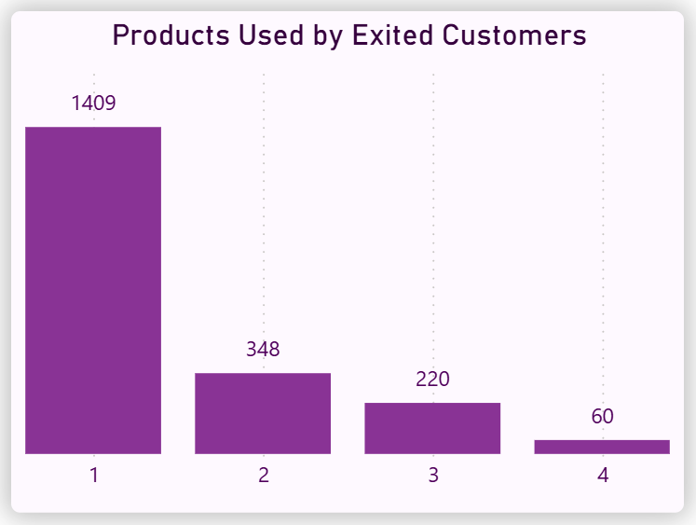
Fig 4
INSIGHT:
- Customers who used 1 product represent the highest number of exited customers (1409).
- Customers with 2, 3, and 4 products have significantly fewer exits.
- This suggests that customers using only a single bank product may be more likely to leave the bank compared to customers using multiple products.

- Examine the trend of customers joining over time and identify any seasonal patterns (yearly or monthly). Prepare the data through SQL and then visualize it?
ANS:
Query Used:
SELECT
YEAR(`Bank DOJ`) AS Join_Year,
COUNT(CustomerId) AS Customers_Joined
FROM Bank_Churn
GROUP BY Join_Year
ORDER BY Join_Year

This analysis examines how the number of customers joining the bank changes over time.
OUTPUT:
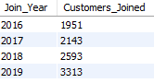
Visualization:
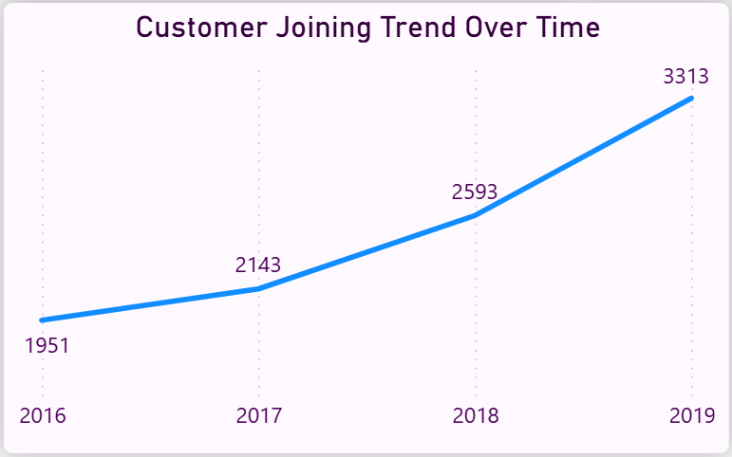
Fig 5
INSIGHT:
- The number of customers joining the bank shows a consistent upward trend from 2016 to 2019.
- Customer acquisition has steadily increased each year, with the highest number observed in 2019.
- This indicates positive growth in the bank’s customer base over time.
- Analyze the relationship between the number of products and the account balance for customers who have exited?
ANS:
This analysis examines how the account balance varies with the number of products used by customers who have exited the bank.
Fields Used:
- X-axis: NumOfProducts
- Y-axis: Balance
- Filter Applied: Exited = 1
Visualization:
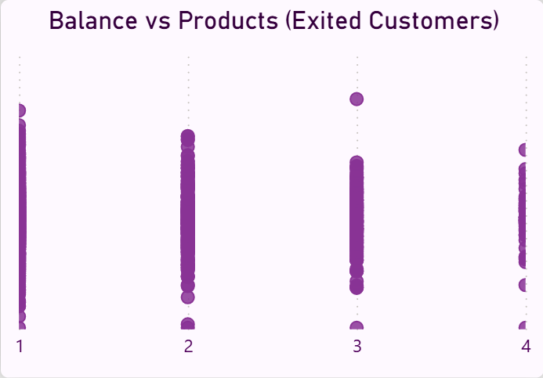
Fig 6
INSIGHT:
- The scatter plot shows that customers who exited are distributed across all product categories, with most customers concentrated around 1 and 2 products.
- There is no clear linear relationship between the number of products and account balance, as balances vary widely within each product group.
- This indicates that the number of products alone does not strongly influence the balance of customers who exited.
- Identify any potential outliers in terms of balance among customers who have remained?
ANS:
This analysis identifies unusual balance values among customers who have remained with the bank.
Fields Used:
- X-axis: CustomerId
- Y-axis: Balance
- Filter Applied: Exited = 0
Visualization:
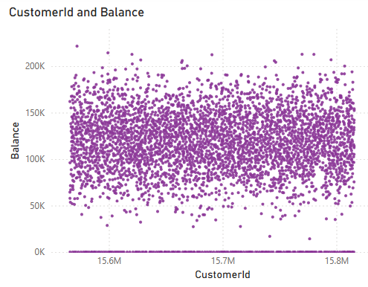
Fig 7
INSIGHT:
- Most retained customers have balances concentrated within a typical range between approximately 50,000 and 180,000.
- However, a few customers exhibit significantly higher balances, particularly above 200,000, indicating potential outliers.
- These high-balance customers may represent premium or high-value clients and are important for the bank’s retention strategy.

- How many different tables are given in the dataset, and which table only consists of categorical variables?
ANS:
The dataset consists of 7 tables. Out of these, the following 5 tables contain only categorical variables:
- activecustomer
• ActiveID (INT)
• ActiveCategory (TEXT)
- creditcard
• CreditID (INT)
• Category (TEXT)
- exitcustomer
• ExitID (INT)
• ExitCategory (TEXT)
- gender
• GenderID (INT)
• GenderCategory (TEXT)
- geography
• GeographyID (INT)
• GeographyLocation (TEXT)
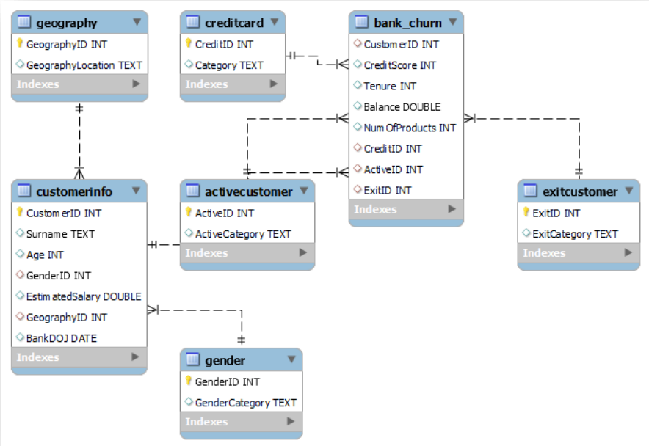
- Find out which geographic region has the highest number of active customers with a tenure greater than 5 years?

ANS:
Query Used:
SELECT GeographyLocation, GenderCategory,
AVG(EstimatedSalary) AS Avg_Income,
RANK() OVER (
PARTITION BY GeographyLocation
ORDER BY AVG(EstimatedSalary) DESC
) AS Rank_In_Geography
FROM Bank_Churn
GROUP BY GeographyLocation, GenderCategory;

This query filters customers who are active members and have a tenure greater than five years, then counts them by geographic location.

OUTPUT:
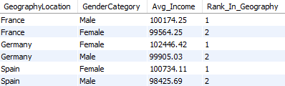
INSIGHT:
- In France, male customers have a slightly higher average income compared to female customers.
- In contrast, in both Germany and Spain, female customers have higher average incomes than male customers.
- This indicates that income distribution by gender varies across different geographic regions, with no consistent dominance of a single gender.
- Find the average tenure of customers who have exited in each age bracket (18–30, 30–50, 50+)(SQL)?

ANS:
Query Used:
SELECT
Age_Group,
AVG(Tenure) AS Avg_Tenure
FROM Bank_Churn
WHERE Exited = 1
GROUP BY Age_Group;

This analysis calculates the average tenure of customers who have exited the bank across different age groups.

OUTPUT:
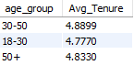
INSIGHT:
- Customers aged 30–50 who exited have the highest average tenure of approximately 4.89 years.
- The average tenure is relatively similar across all age groups, indicating that customers tend to leave the bank after a comparable duration regardless of age.
- This suggests that tenure alone may not be a strong differentiating factor for churn across age groups.

- Identify any potential outliers in terms of balance among customers who have remained?
ANS:
This analysis examines whether there is a relationship between customers’ estimated salary and their account balance, and compares this pattern for exited and retained customers.
Fields Used:
- X-axis: EstimatedSalary
- Y-axis: Balance
- Legend: Exited
Visualization:
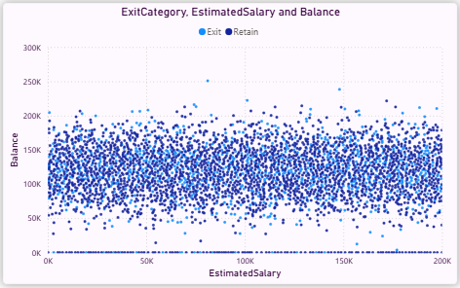
Fig 8
INSIGHT:
- The scatter plot shows no clear linear relationship between estimated salary and account balance, as the data points are widely dispersed.
- Both exited and retained customers exhibit a similar distribution pattern, indicating that salary does not significantly influence balance behavior.
- This suggests that there is no strong correlation between salary and balance, and this relationship does not differ meaningfully between exited and retained customers.
- Is there any correlation between salary and credit score of customers?
ANS:
This analysis examines whether there is any relationship between customers’ estimated salary and their credit score.
Fields Used:
- X-axis: EstimatedSalary
- Y-axis: CreditScore
Visualization:
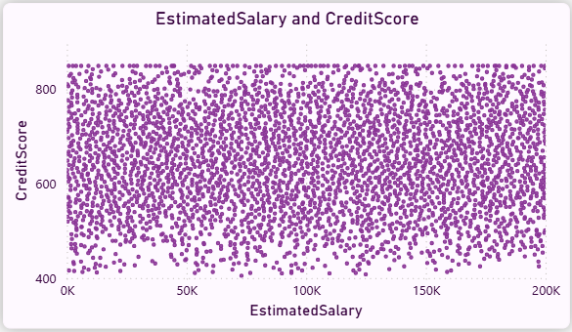
Fig 9
INSIGHT:
- The scatter plot shows that data points are widely dispersed with no clear upward or downward trend.
- Customers with both high and low salaries exhibit a wide range of credit scores, indicating no consistent pattern.
- This suggests that there is no strong correlation between estimated salary and credit score in the dataset.

- Rank each bucket of credit score as per the number of customers who have churned the bank?

ANS:
Query Used:
SELECT CreditScoreGroup,
COUNT(CustomerId) AS Churned_Customers,
RANK() OVER (ORDER BY COUNT(CustomerId) DESC) AS Rank_By_Churn
FROM Bank_Churn
WHERE Exited = 1
GROUP BY CreditScoreGroup;

This analysis ranks credit score segments based on the number of customers who have exited the bank.

OUTPUT:
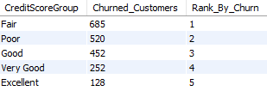
INSIGHT:
- Customers in the Fair credit score group have the highest number of churned customers, followed by the Poor group.
- In contrast, customers with Excellent credit scores have the lowest churn count.
- This indicates that mid-range credit score customers contribute more to overall churn compared to high credit score customers.

- According to age buckets, find the number of customers who have a credit card. Also retrieve those buckets that have lesser than average number of credit cards per bucket. (SQL)?

ANS:
Query Used:
WITH Age_Card_Count AS (
SELECT
Age_Group,
COUNT(CustomerId) AS CreditCard_Customers
FROM Bank_Churn
WHERE HasCrCard = 1
GROUP BY Age_Group
),
Avg_Value AS (
SELECT AVG(CreditCard_Customers) AS Avg_Cards
FROM Age_Card_Count
)
SELECT
a.Age_Group,
a.CreditCard_Customers
FROM Age_Card_Count a, Avg_Value b
WHERE a.CreditCard_Customers < b.Avg_Cards;

This analysis ranks credit score segments based on the number of customers who have exited the bank.

OUTPUT:
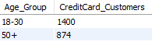
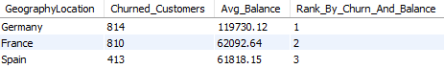

INSIGHT:
- The 18–30 and 50+ age groups have a lower-than-average number of customers holding credit cards.
- In contrast, the 30–50 age group has a higher concentration of credit card users.
- This suggests that middle-aged customers are more likely to adopt credit card services compared to younger and older age groups.

- According to age buckets, find the number of customers who have a credit card. Also retrieve those buckets that have lesser than average number of credit cards per bucket. (SQL)?

ANS:
Query Used:
SELECT
GeographyLocation,
COUNT(CASE WHEN Exited = 1 THEN 1 END) AS Churned_Customers,
ROUND(AVG(Balance),2) AS Avg_Balance,
RANK() OVER (
ORDER BY COUNT(CASE WHEN Exited = 1 THEN 1 END) DESC,
AVG(Balance) DESC
) AS Rank_By_Churn_And_Balance
FROM Bank_Churn
GROUP BY GeographyLocation;

This analysis ranks credit score segments based on the number of customers who have exited the bank.

OUTPUT:

INSIGHT:
- Germany ranks highest with the largest number of churned customers and the highest average balance, indicating a significant loss of high-value customers.
- France follows with a similar churn count but a lower average balance, while Spain has the lowest churn and average balance.
- This suggests that customer churn in Germany may have a greater financial impact compared to other regions

- As we can see that the “CustomerInfo” table has the CustomerID and Surname, now if we have to join it with a table where the primary key is also a combination of CustomerID and Surname, come up with a column where the format is “CustomerID_Surname”?

ANS:
Query Used:
SELECT
CustomerId,
Surname,
CONCAT(CustomerId, '_', Surname) AS CustomerID_Surname
FROM bank_churn;

This task creates a new column by combining CustomerId and Surname using an underscore as a separator.

OUTPUT:
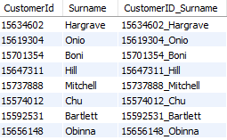
INSIGHT:
- A new column CustomerID_Surname has been successfully created by combining CustomerId and Surname.
- This format can be useful as a composite key for joining tables where both fields together act as a primary identifier.

- Without using “Join”, can we get the “ExitCategory” from ExitCustomers table to Bank_Churn table? If yes do this using SQL
ANS:

Since, I have consolidated the dataset into a master table(Bank_Churn), the ExitCategory column is already available.Therefore, no additional query is required to retrieve it.

Query Used:
SELECT
b.CustomerID,
b.CreditScore,
b.Balance,
b.ExitID,
(
SELECT e.ExitCategory
FROM ExitCustomer e
WHERE e.ExitID = b.ExitID
) AS ExitCategory
FROM Bank_Churn b
ORDER BY b.Balance DESC;

- In a normalized database structure, subqueries can be used to retrieve related data without using joins.
- However, in a consolidated master dataset, such operations become unnecessary as all required fields are already present.
- This improves query simplicity and performance.

- Were there any missing values in the data, using which tool did you replace them and what are the ways to handle them?

ANS:

During data preprocessing, the dataset was checked for missing values across all columns.
- No significant missing values were observed in the dataset
.
Handling Method:
If missing values were present, the following approaches can be used
- Numerical columns: Replace with mean/median.
- Categorical columns: Replace with mode.
- Remove rows: If missing values are very few.
- Imputation: Based on business logic
In this project, data cleaning was performed during the preparation stage using Excel / Power BI, ensuring consistency and completeness of the dataset.
INSIGHT:
The dataset was found to be clean and well-structured with no major missing values affecting the analysis.Proper handling of missing values ensures accuracy and reliability of insights derived from the data.This step is crucial in maintaining the quality of analytical results.

- Write the query to get the customer IDs, their last name, and whether they are active or not for the customers whose surname ends with “on”?

ANS:
Query Used:
SELECT
CustomerId,
Surname,
ActiveCategory
FROM Bank_Churn
WHERE Surname LIKE '%on';

This query retrieves customer IDs, surnames, and their activity status for customers whose surname ends with “on”.

OUTPUT:
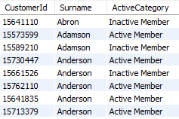
INSIGHT:
- This query retrieves customer IDs, surnames, and their activity status for customers whose surname ends with “on”.
- This shows that surname patterns do not influence customer activity behavior.

- Can you observe any data discrepancy in the Customer’s data? As a hint it’s present in the IsActiveMember and Exited columns. One more point to consider is that the data in the Exited Column is absolutely correct and accurate?
ANS:
Yes, a data discrepancy can be observed between the IsActiveMember and Exited columns.
- Ideally, active members (IsActiveMember = 1) are expected to have a lower probability of exiting
- However, the dataset shows that some customers are marked as active (1) while also being marked as exited (1)

Explanation
Since the Exited column is considered correct, this indicates that:
- The IsActiveMember field may not be updated properly after a customer exits, or
- There is a lag/inconsistency in status tracking

INSIGHT
- The presence of customers marked as both active and exited highlights a potential data inconsistency in the dataset.
- This suggests that the IsActiveMember column may not accurately reflect the current status of customers.
- Such discrepancies should be addressed to improve data quality and ensure reliable analysis.

SUBJECTIVE QUESTIONS

- What patterns can be observed in the spending habits of long-term customers compared to new customers, and what might these patterns suggest about customer loyalty?

ANS :

QUERY USED:

SELECT
CASE
WHEN Tenure >= 7 THEN 'Long-Term'
WHEN Tenure <= 3 THEN 'New'
ELSE 'Mid-Term'
END AS Customer_Type,
COUNT(*) AS Total_Customers,
ROUND(AVG(Balance),2) AS Avg_Balance,
ROUND(AVG(NumOfProducts),2) AS Avg_Products,
ROUND(AVG(IsActiveMember)*100,2) AS Active_Rate,
ROUND(AVG(Exited)*100,2) AS Churn_Rate
FROM bank_churn
GROUP BY Customer_Type;

OUTPUT:

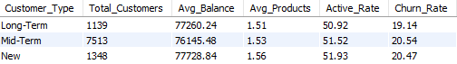

VISUALIZATION:
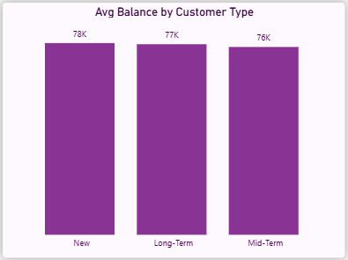
Fig 1: Avg Balance by Customer Type

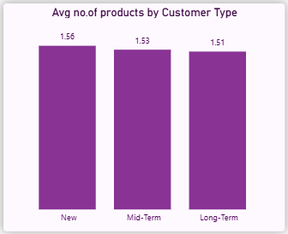
Fig 2: Avg Number of Products by Customer Type

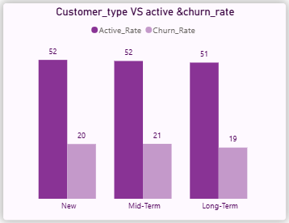
Fig 3: Active Rate vs Churn Rate by Customer Type

Insight :
- There is no significant difference in average balance across customer types, with all groups maintaining balances around 76K–78K. This indicates consistent spending capacity across tenure levels.
- New customers show a slightly higher average number of products (1.56) compared to long-term customers (1.51), suggesting initial engagement is marginally higher but not sustained.
- Active rates are almost identical (~51–52%) across all groups, indicating that customer activity does not significantly improve with tenure.
- Churn rates are also very similar (~19–21%), meaning long-term customers are not significantly more loyal than new customers.
Recommendations:
- The bank should focus on increasing product engagement for long-term customers, as they currently use fewer products despite longer tenure.
- Since churn rates are consistent across all segments, the bank should implement uniform retention strategies, rather than targeting only new or long-term customers.
- Introduce loyalty programs or rewards for long-term customers to strengthen retention, as tenure alone is not translating into loyalty.
- Enhance cross-selling strategies early in the customer lifecycle, since new customers already show slightly higher product adoption.

- Product Affinity Study: Which bank products or services are most commonly used together, and how might this influence cross-selling strategies?
ANS :

QUERY USED:

SELECT NumOfProducts,COUNT(CustomerId) AS Total_Customers,
ROUND(AVG(Exited)*100,2) AS Churn_Rate,
ROUND(AVG(IsActiveMember)*100,2) AS Active_Rate
FROM bank_churn
GROUP BY NumOfProducts
ORDER BY NumOfProducts;
GROUP BY Customer_Type;

OUTPUT:

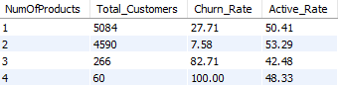

VISUALIZATION:
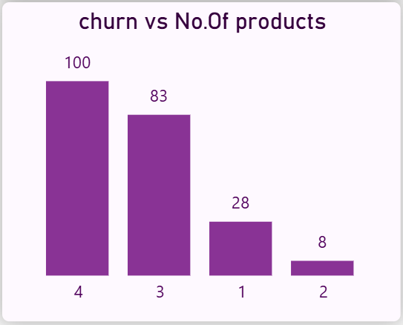
Fig 1: Number of Customers vs Number of Products

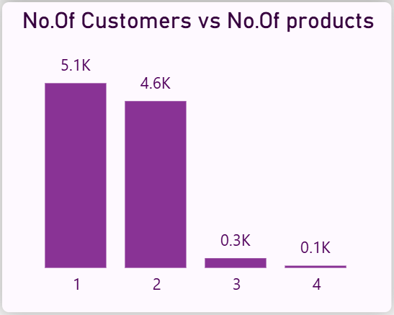
Fig 2: Avg Number of Products by Customer Type

Insight :
- Most customers use 1 or 2 products, indicating that product adoption is generally low and concentrated in fewer services.
- Customers with 2 products have the lowest churn rate (7.58%), showing that moderate product usage is strongly associated with higher retention.
- Customers with only 1 product have a significantly higher churn rate (~27.7%), suggesting low engagement leads to higher exit probability.
- Extremely high churn rates for 3 and 4 products (82% and 100%) are misleading due to very small sample sizes, and should not be over-interpreted.
Recommendations:
- The bank should focus on converting 1-product customers into 2-product customers, as this transition shows the strongest improvement in retention.
- Implement targeted cross-selling strategies for customers with only one product, such as bundled offers or personalized recommendations.
- Avoid over-targeting customers with already high product counts, as the data for 3+ products is limited and unreliable.
- Introduce engagement-driven campaigns to increase product adoption early in the customer lifecycle.

- How do economic indicators in different geographic regions correlate with the number of active accounts and customer churn rates?
ANS :

QUERY USED:

SELECT
GeographyLocation,
COUNT(CustomerId) AS Total_Customers,
ROUND(AVG(Balance),2) AS Avg_Balance,
ROUND(AVG(EstimatedSalary),2) AS Avg_Salary,
ROUND(AVG(IsActiveMember)*100,2) AS Active_Rate,
ROUND(AVG(Exited)*100,2) AS Churn_Rate
FROM Bank_Churn
GROUP BY GeographyLocation
ORDER BY Avg_Balance DESC;

OUTPUT:

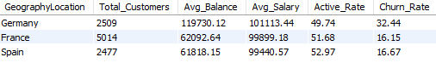

VISUALIZATION:

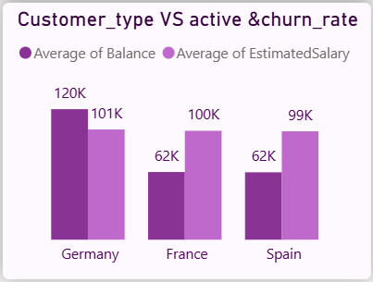
Fig 1: Avg Balance & Salary by Geography
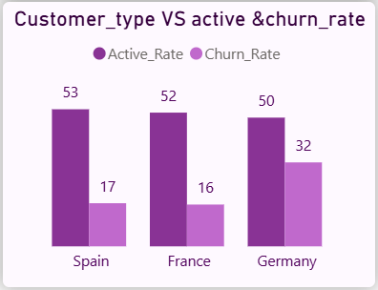
Fig 2: Active Rate & Churn Rate by Geography

Insight :
- Germany has significantly higher average balances (~120K) compared to France and Spain (~62K), indicating stronger financial capacity among customers.
- Despite higher financial strength, Germany shows a very high churn rate (~32.44%), which is almost double that of France and Spain (~16%).
- France and Spain, although having lower balances, maintain higher active rates (~52%) and lower churn, indicating more stable customer engagement.
- This clearly shows that higher financial value does not guarantee customer retention, especially in the German region.
Recommendations:
- The bank should prioritize retention strategies in Germany, as it is losing high-value customers, leading to significant financial impact.
- Conduct deeper analysis in Germany to identify causes of churn (e.g., service dissatisfaction, competition, pricing issues).
- France and Spain can be used as benchmark regions to understand what drives better retention and customer engagement.
- Introduce premium retention programs specifically for high-balance customers in Germany to reduce churn risk.

- Based on customer profiles, which demographic segments appear to pose the highest financial risk to the bank, and why?

ANS :

QUERY USED:

SELECT
Age_Group,
GenderCategory,
GeographyLocation,
COUNT(CustomerId) AS Total_Customers,
ROUND(AVG(Balance),2) AS Avg_Balance,
ROUND(AVG(Exited)*100,2) AS Churn_Rate
FROM Bank_Churn
GROUP BY Age_Group, GenderCategory, GeographyLocation
ORDER BY Churn_Rate DESC
LIMIT 10;

OUTPUT:

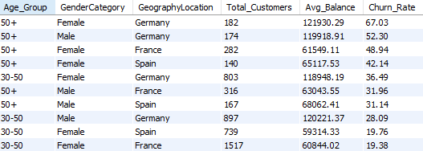

VISUALIZATION:
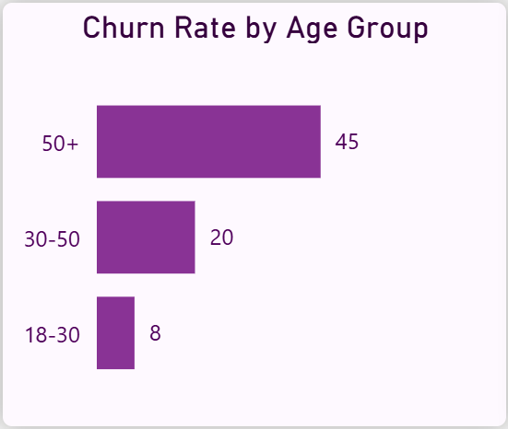
Fig 1: Churn Rate by Age Group
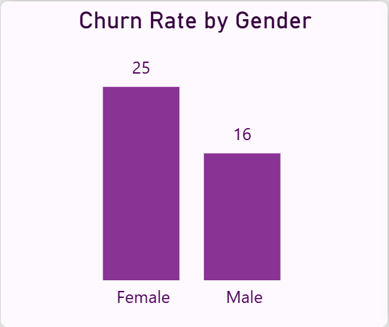
Fig 2: Churn Rate by Gender
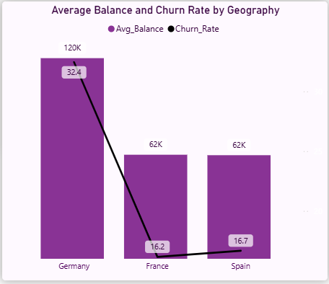
Fig 3: Average Balance and Churn Rate by Geography

Insight :
- Customers aged 50+ consistently show the highest churn rates across all regions, making them the most vulnerable demographic segment.
- The highest financial risk segment is 50+ Female customers in Germany, as they combine: Very high balance (~121K), Very high churn (~67%)
- Germany stands out as the highest risk geography, with multiple high-churn segments and high average balances.
- Female customers in older age groups show higher churn compared to males, indicating a gender-based retention gap in senior segments.
- Customers aged 30–50 show moderate risk, while younger customers exhibit relatively lower churn.
Recommendations:
- The bank should prioritize retention strategies for 50+ customers, especially in Germany, as they represent high-value accounts with high churn risk.
- Develop personalized engagement programs for older female customers, including financial advisory services and tailored offers.
- Implement region-specific retention strategies in Germany, focusing on high-balance customers.
- Strengthen relationship management for high-value customers to reduce financial loss due to churn.

- How would you use the available data to model and predict the lifetime (tenure) value in the bank of different customer segments??

ANS :

Since the dataset does not contain direct revenue or transaction-level data, an estimated customer value is derived using Balance and Tenure as a proxy. Customers are then segmented by age group and geography to compare value contribution along with churn behavior.

QUERY USED:

SELECT
Age_Group,
GeographyLocation,
ROUND(AVG(Balance * Tenure),2) AS Avg_Customer_Value,
ROUND(AVG(Exited)*100,2) AS Churn_Rate
FROM Bank_Churn
GROUP BY Age_Group, GeographyLocation
ORDER BY Avg_Customer_Value DESC;

OUTPUT:

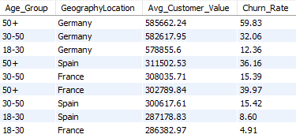

VISUALIZATION:
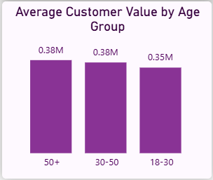
Fig 1: Churn Rate by Age Group
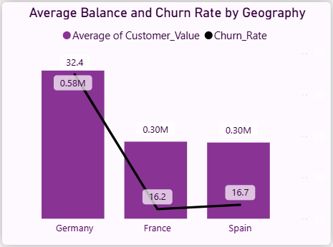
Fig 2: Customer Value vs Churn Rate by Geography

Insight :
- Customers aged 50+ generate the highest estimated value, especially in Germany.
- However, these high-value segments also show very high churn rates (~59.83%), making them the most critical risk group
- Germany consistently shows highest customer value but also highest churn, indicating that the bank is losing its most valuable customers.
- Younger customers (18–30) have lower value but significantly lower churn, making them more stable but less profitable.
Recommendations:
- Focus on retaining high-value customers (50+ in Germany) through personalized services and loyalty benefits.
- Introduce early engagement strategies for mid-age customers (30–50) to reduce future churn risk.
- Develop long-term value-building strategies for younger customers, as they show strong retention potential.
- Implement predictive monitoring for high-value segments to identify churn signals early.

- How could you assess the impact of marketing campaigns on customer retention and acquisition within the dataset? What extra information would you need to solve this?

ANS :
Approach
The dataset does not contain direct information about marketing campaigns, so campaign effectiveness cannot be measured directly. Instead, customer retention and acquisition trends are analyzed as indirect indicators, and additional data requirements are identified to perform a complete evaluation.

Analysis:
- Customer retention can be assessed using churn rate trends over time.
- Customer acquisition can be analyzed using the number of customers joining across different periods
- No timestamps linking campaigns to customer behavior.
Limitations:
- No campaign identifiers or campaign participation data.
- No information on marketing spend or channels.
- Develop long-term value-building strategies for younger customers, as they show strong retention potential.
- Implement predictive monitoring for high-value segments to identify churn signals early.
Therefore, direct measurement of campaign effectiveness is not possible
Additional Data Required
To properly evaluate marketing campaigns, the following data is needed:
- Campaign ID or campaign participation flag
- Marketing channel (email, social media, ads, etc.)
- Campaign duration and timeline
- Cost of each campaign
- Customer response data (clicks, conversions, sign-ups)
Insight :
- Current dataset allows only indirect observation of trends, not campaign impact.
- Without campaign-level data, it is not possible to determine which marketing efforts influenced retention or acquisition
Recommendations:
- Integrate marketing campaign data with customer records for future analysis.
- Track campaign performance using metrics such as conversion rate and retention rate.
- Build a structured system to link customer behavior with campaign exposure.

- Can you identify common characteristics or trends among customers who have exited that could explain their reasons for leaving

ANS :
Approach
Since the dataset does not include explicit exit reasons, the analysis focuses on identifying behavioral patterns among customers who have exited. Key factors such as product usage, credit card ownership, and geographic distribution are examined to infer possible drivers of churn.
VISUALIZATION:
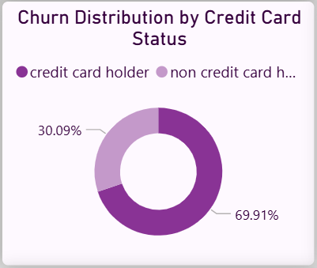
Fig 1: Churn Distribution by Credit Card Status
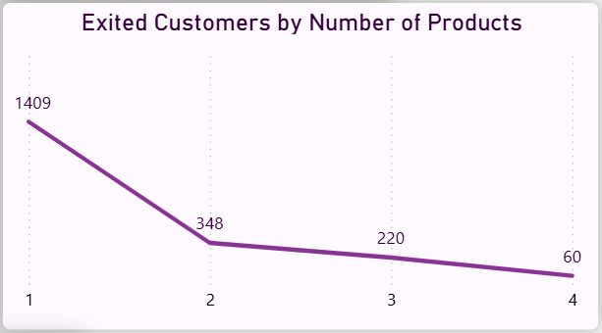
Fig 2: Exited Customers by Number of Products

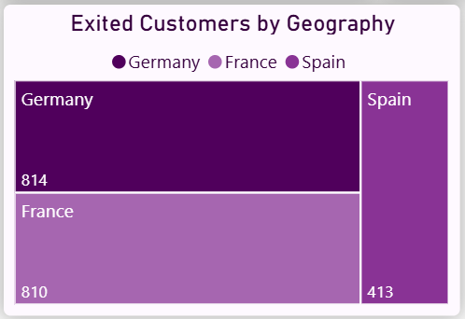
Fig 3: Exited Customers by Geography
Insight :
- Focus on increasing product engagement, especially converting single-product customers into multi-product users.
- Implement targeted retention strategies for low-engagement customers, as they are more likely to churn.
- Monitor high-churn regions like Germany and France to identify region-specific issues.
- Strengthen customer relationship depth through cross-selling and personalized offerings.
Recommendations:
- Focus on increasing product engagement, especially converting single-product customers into multi-product users.
- Implement targeted retention strategies for low-engagement customers, as they are more likely to churn.
- Monitor high-churn regions like Germany and France to identify region-specific issues.
- Strengthen customer relationship depth through cross-selling and personalized offerings.

- Are Tenure, NumOfProducts, IsActiveMember, and EstimatedSalary important for predicting if a customer will leave the bank?

ANS :

Approach
The importance of each feature is evaluated by analyzing its relationship with churn rate using Power BI visualizations. Each variable is compared against churn to identify whether it shows a strong, moderate, or weak influence on customer exit behavior.
VISUALIZATION:

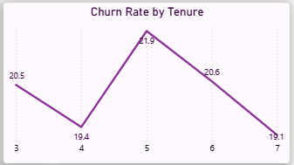
Fig 1: Churn Rate by Tenure
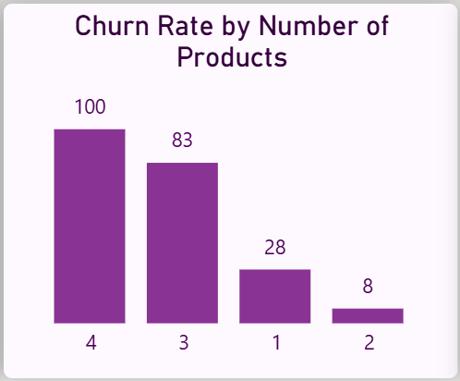
Fig 2: Churn Rate by Number of Products
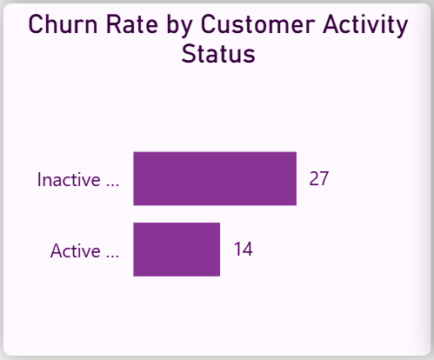
Fig 3: Churn Rate by Customer Activity Status
Insight :
- NumOfProducts is the strongest predictor:
  - Customers with 1 product show high churn (~27–28%)
  - Customers with 2 products show very low churn (~7–8%)
  - Indicates strong relationship between product usage and retention
- IsActiveMember is also highly important:
  - Inactive customers → ~27% churn
  - Active customers → ~14% churn
  - Engagement plays a critical role
- Tenure shows moderate influence:
  - Churn fluctuates across tenure (around ~19–22%)
  - No consistent increasing or decreasing trend
  - Weak to moderate predictor
- EstimatedSalary shows no meaningful relationship:
  - Churn remains almost constant (~19–21%) across all salary groups
  - Salary is NOT a useful predictor
Conclusion (Feature Importance Ranking)
From strongest to weakest:
- NumOfProducts (Very Strong)
- IsActiveMember (Strong)
- Tenure (Moderate)
- EstimatedSalary (Weak / No impact)
Recommendations:
- Focus predictive models on product usage and customer activity, as they provide the highest signal for churn.
- Develop strategies to increase product adoption and customer engagement, as these directly reduce churn risk.
- Avoid relying on salary as a key decision factor, as it does not significantly influence churn behaviour.

- How would you use the available data to model and predict the lifetime (tenure) value in the bank of different customer segments??

ANS :

APPROACH:
Customers are segmented into meaningful business categories based on balance, tenure, product usage, and activity status. These segments help identify high-value, high-risk, and low-engagement customers for targeted strategies.

High-Value Customers:

SELECT CustomerId, Age_Group, GeographyLocation,
Balance,Tenure
FROM Bank_Churn
WHERE Balance > 100000
AND Tenure > 5;

- Customers with high balances (>100K) and longer tenure (>5 years)
- Example: Customers from France, Spain, and Germany with balances above 100K

High-Risk Customers:

SELECT CustomerId, Age_Group, GeographyLocation,
NumOfProducts, IsActiveMember, Exited
FROM Bank_Churn
WHERE Exited = 1
AND NumOfProducts = 1
AND IsActiveMember = 0;
- Customers who have only 1 product, are inactive, have already exited
- Represents highest churn-risk behavior pattern
Low-Engagement Customers:

SELECT
CustomerId,
Age_Group,
NumOfProducts,
IsActiveMember
FROM Bank_Churn
WHERE NumOfProducts = 1
AND IsActiveMember = 0;
- Customers who have only 1 product, are inactive, have already exited
- Represents highest churn-risk behavior pattern
Insight :
- High-value customers are identified by high balance and long tenure, making them important for retention.
- High-risk customers share common traits
- Single product
- Inactive status
- Already churned
- Low-engagement customers show early signs of churn, indicating the need for proactive intervention.

Recommendations:
- Focus retention efforts on high-value customers to prevent financial loss.
- Target high-risk customers with immediate interventions, such as personalized offers.
- Improve engagement for low-engagement customers by promoting multi-product usage and activity.

- How can we create a conditional formatting setup to visually highlight customers at risk of churn and to evaluate the impact of credit card rewards on customer retention?

ANS :

Approach
A rule-based risk classification is developed using key behavioral features such as product usage, activity status, and churn. Conditional formatting is applied in Power BI tables to visually highlight risk levels. Credit card impact is evaluated by comparing churn distribution and churn rates between card holders and non-holders.
OUTPUT:
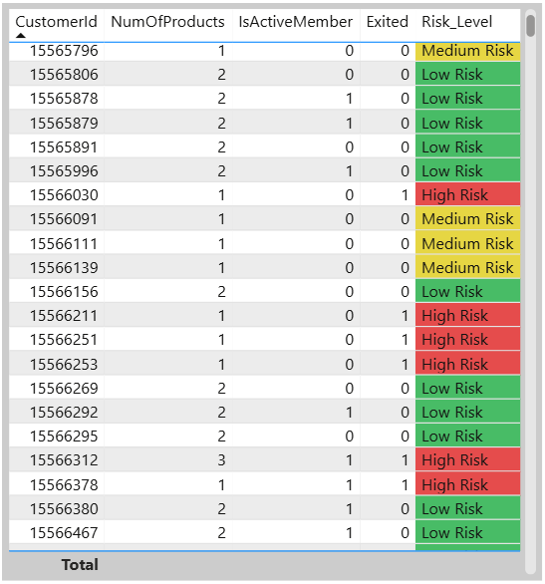
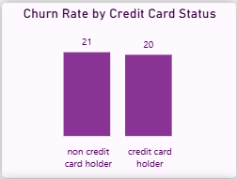
Fig 1:Churn Rate by Credit Card Status
Insight :
- Medium-risk customers are clearly identified as those with low engagement (1 product + inactive), indicating early signs of churn.
- Conditional formatting enables quick visual identification of at-risk customers, improving monitoring efficiency.
- Although 69.91% of churned customers are credit card holders, this is due to their higher population in the dataset.
- The churn rate difference is minimal:
  - Non-credit → ~21%
  - Credit → ~20%
- This shows that credit card ownership alone does not significantly influence retention.
Recommendations:
- Focus on improving customer engagement (activity + product usage) rather than relying only on credit card features.
- Use conditional formatting dashboards to track and act on medium-risk customers early.
- Enhance credit card offerings with personalized rewards and bundled services, instead of treating card ownership as a retention driver.
Conditional Formatting Rules:
- Risk_Level Column:
  - High Risk → Highlighted in Red (Exited customers)
  - Medium Risk → Highlighted in Yellow (Inactive + single product customers
  - Low Risk → Highlighted in Green (Active or multi-product customers)
- This rule-based formatting helps in quick visual identification of at-risk customers without detailed analysis
- What is the current churn rate per year and overall as well in the bank? Can you suggest some insights to the bank about which kind of customers are more likely to churn and what different strategies can be used to decrease the churn rate?

ANS :

Approach
Churn rate is analyzed over time using customer joining year as a proxy, along with overall churn rate using aggregate measures. Previously identified churn patterns (product usage, activity, demographics, geography) are used to identify high-risk segments and suggest strategies.
OUTPUT:
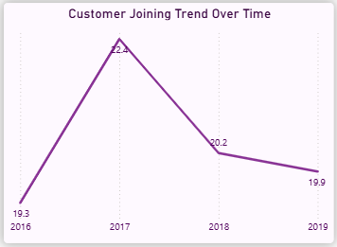
Fig 1: Churn Rate by Year
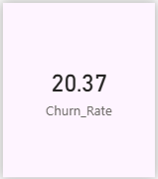
Fig 2: Overall Churn Rate
Insight :
- Churn rate peaked in 2017 (~22.4%), indicating a period of higher customer exit.
- Churn shows a slight decline after 2017, stabilizing around ~20%.
- Overall churn (~20.37%) indicates that 1 in 5 customers is leaving, which is significant.
- Based on earlier analysis, customers more likely to churn include:
  - Customers with only 1 product
  - Inactive customers
  - Customers aged 50+
  - Customers from Germany
Recommendations:
- Focus on increasing product adoption, especially converting single-product users into multi-product customers.
- Improve customer engagement programs to reduce inactivity.
- Implement targeted retention strategies for high-risk groups, such as older customers and specific regions.
- Monitor churn trends periodically to detect spikes (like in 2017) and take timely action

- How would you approach this problem, if the objective and subjective questions weren't given?
Approach:
If objective and subjective questions were not provided, I would approach the Bank_Churn analysis with a structured, insight-driven method focused on identifying churn drivers and business opportunities.
- Understand the Schema:
Start by reviewing the ER diagram and key tables such as CustomerInfo, Bank_Churn, and ExitCustomer to understand relationships and data flow.
- Data Preparation:
Clean the dataset by handling missing values, fixing inconsistencies, renaming or formatting columns, and creating unique identifiers for reliable joins.
- Key Metrics:
Measure and track important indicators like overall churn rate, product usage trends, credit score influence, and tenure-based customer lifetime value.
- Customer Segmentation:
Categorize customers by demographics, account characteristics, and churn behavior to identify patterns in loyalty and attrition.
- SQL-Based Insights:
  - Analyze churn trends by year, geography, and gender.
  - Study product affinity to uncover potential cross-sell opportunities.
  - Evaluate credit score impact on churn likelihood.
  - Examine retention patterns based on product usage levels.
- Visualization:
Build dashboards that display churn trends, segment performance, and product usage.
Use conditional formatting to highlight at-risk customers and time-series visuals to track churn over time.
Recommendations:
- Retention:
Implement loyalty programs, personalized offers, and proactive engagement strategies for customers identified as high-risk.
- Cross-Selling:
Design product bundles and targeted campaigns based on customer affinity to increase engagement and lifetime value.
- Credit Score Improvement:
Offer financial counseling and tailored credit-building programs for low-score customers to strengthen trust and reduce churn.

- In the “Bank_Churn” table how can you modify the name of the “HasCrCard” column to “Has_creditcard”?

ANS :

The column name is modified using the ALTER TABLE statement to improve readability and maintain consistent naming conventions in the dataset. This helps in better understanding and usage of the column during analysis and visualization.

QUERY:

ALTER TABLE Bank_Churn
CHANGE HasCrCard Has_creditcard INT;

